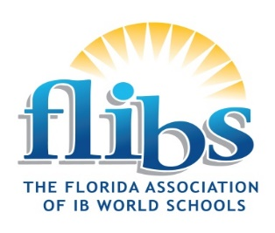


FLIBS Quarterly Meeting 14 February 2025
Time | Bird/Indian/Long
7:00-8:00 | Breakfast
8:00 – 12:00 | AI Practice in IB Schools: From Inquiry to Impact  Facilitated by Michelle Lackovic and Allison Navas  Discover how generative AI can amplify student inquiry and learning through the  International Baccalaureate frameworks. This hands-on, 5-hour workshop guides  educators in practical integration of AI tools to enhance critical thinking, research, and  communication skills.
12:00-1:30 | Lunch on your own
1:30-2:45 | Continuation of morning session

